PIZZA SALES SQL QUERIES
A. KPI’s
1. Total Revenue:
select sum(total price) as Total_Sales from pizza_sales;
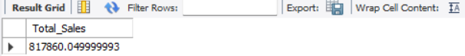

2. Average Order Value
select sum(total_price)/count(distinct(order_id)) as Avg_Order_value from pizza_sales;
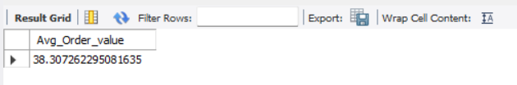

3. Total Pizzas Sold
select sum(quantity) as Total_Pizzas_Sold from pizza_sales;
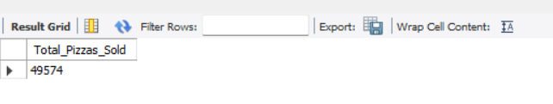

4. Total Orders
select count(distinct(order_id)) as Total_Orders from pizza_sales;
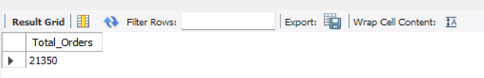

5. Average Pizzas Per Order
select round(sum(quantity)/count(distinct(order_id)),2) as pizza_per_order from pizza_sales;
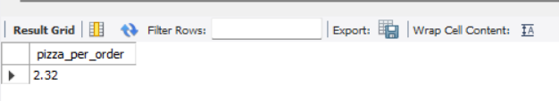

B. Daily Trend for Total Orders
SELECT DATENAME(DW, order_date) AS order_day, COUNT(DISTINCT order_id) AS total_orders
FROM pizza_sales
GROUP BY DATENAME(DW, order_date)
Output:
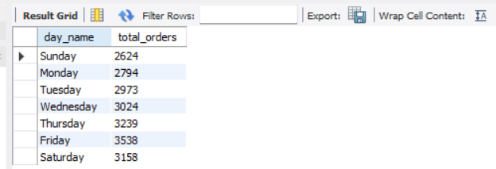

C. Hourly Trend for Orders
SELECT
HOUR(STR_TO_DATE(order_time, '%H:%i:%s')) AS order_hours,
COUNT(DISTINCT order_id) AS total_orders
FROM pizza_sales
GROUP BY HOUR(STR_TO_DATE(order_time, '%H:%i:%s'))
ORDER BY order_hours;
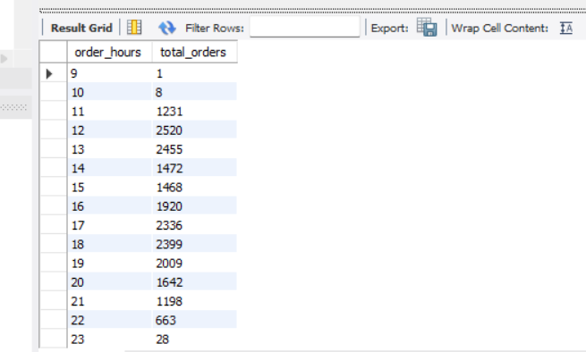

D. % of Sales by Pizza Category
select pizza_category,round(sum(total_price),2),round(sum(total_price)*100/(select sum(total_price) from pizza_sales),2) as PCT
from pizza_sales
group by pizza_category;
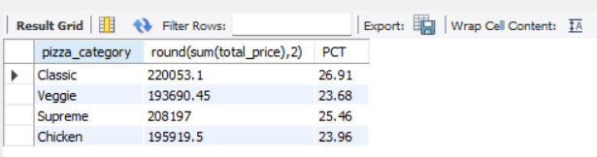

E. % of Sales by Pizza Size
select pizza_size,round(sum(total_price),2) as Total_sales,round(sum(total_price)*100/(select sum(total_price) from pizza_sales),2) as PCT
from pizza_sales
group by pizza_size
order by pizza_size;
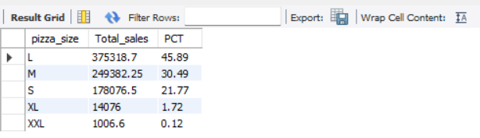

F. Total Pizzas Sold by Pizza Category
select pizza_category,sum(quantity) as total_sales
from pizza_sales
group by pizza_category
order by sum(quantity) desc;
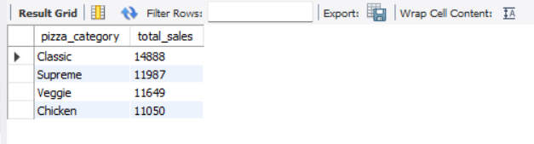

G. Top 5 Best Sellers by Total Pizzas Sold
select pizza_name , sum(quantity) as total_quantities_sold
from pizza_sales
group by pizza_name
order by sum(quantity) desc
limit 5;
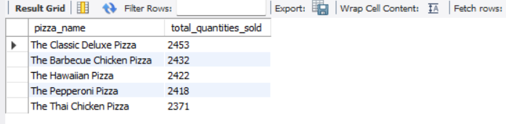

H. Bottom 5 Best Sellers by Total Pizzas Sold
select pizza_name , sum(quantity) as total_quantities_sold
from pizza_sales
group by pizza_name
order by sum(quantity)
limit 5;
